TUTORIAL – 14
Selenium Web Automation
Project Name | Selenium Web Automation
Module Name | Login and Product Navigation
Test Case ID | TC-14-01
Tester Name | Vidhi Patel
Application Under Test | SauceDemo Web Application  (https://www.saucedemo.com/)
Tools Used | Python, PyCharm, Selenium WebDriver, Google Chrome
SDLC Model | Agile
Automation Scenario Table
Scenario ID | Scenario | Module / Page | Expected Result
1 | Browser Navigation | Login Page | Website opens
2 | Form Handling | Login | Credentials entered
3 | Web Element Interaction | Products | Product selected
4 | Validation Testing | Products / Cart | URL / title validated

Test Scenarios with Screenshots
Scenario WEB01: Open website
Scenario ID | WEB01
Scenario | Open website
Test Steps | 1. Run the Python script.  2. Launch the browser.  3. Navigate to https://www.saucedemo.com/.
Expected Result | Login page opens successfully.
Actual Result | Login page opens successfully.
Status | Pass
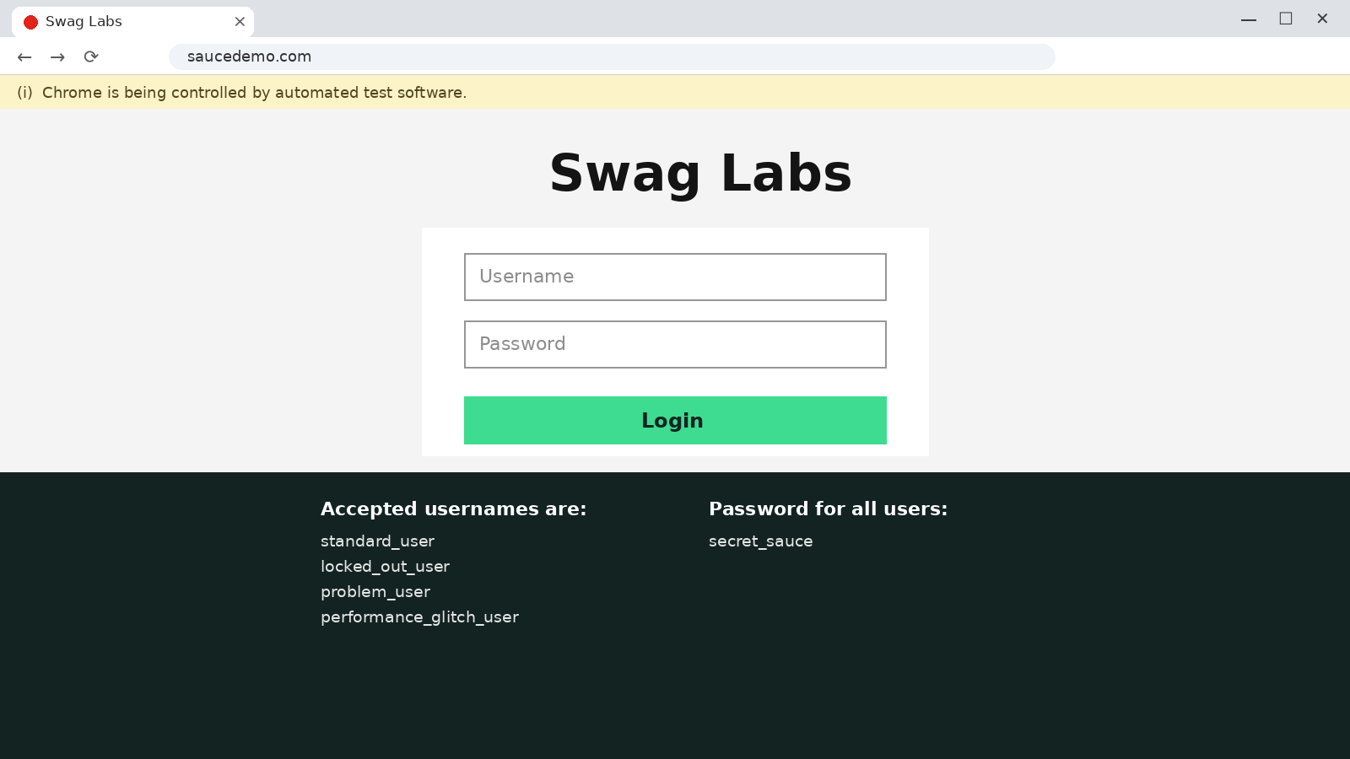
Figure 1: SauceDemo login page opened by Selenium
Scenario WEB02: Enter login credentials
Scenario ID | WEB02
Scenario | Enter login credentials
Test Steps | 1. Locate the username and password fields.  2. Enter standard_user and secret_sauce.  3. Verify the values are entered.
Expected Result | Credentials are entered in the login form.
Actual Result | Credentials are entered in the login form.
Status | Pass
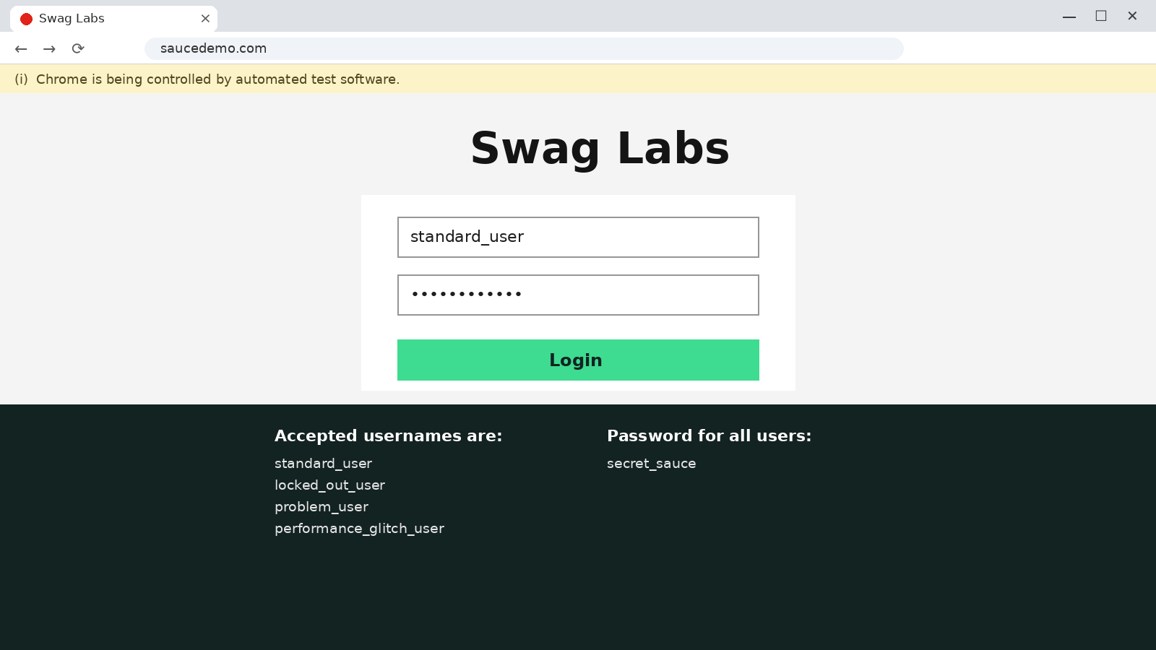
Figure 2: Username and password entered by Selenium
Scenario WEB03: Login and validate Products page
Scenario ID | WEB03
Scenario | Login and validate Products page
Test Steps | 1. Click the Login button.  2. Wait for the inventory page.  3. Validate that "inventory" is in the URL.
Expected Result | Products page opens and URL is validated.
Actual Result | Products page opens and URL is validated.
Status | Pass
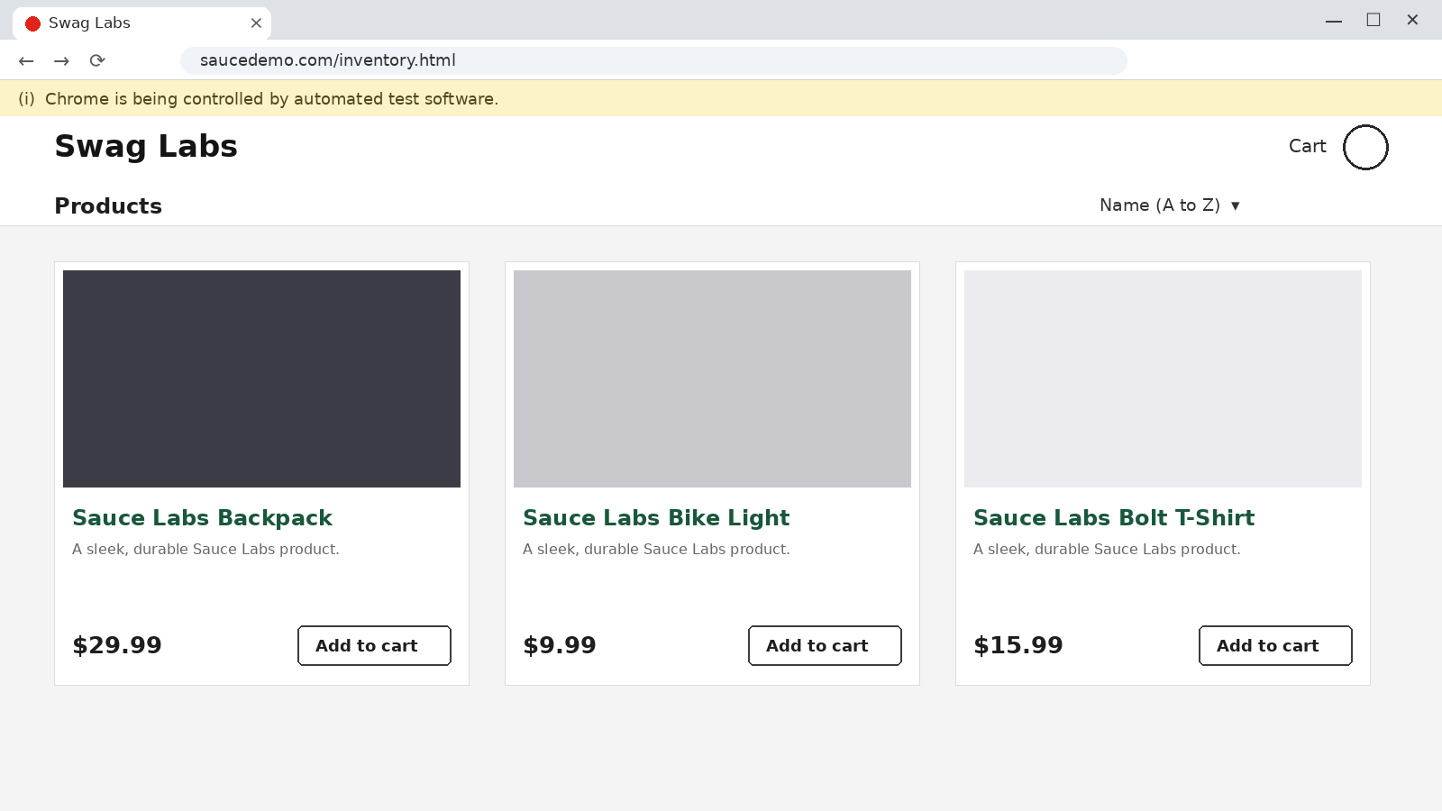
Figure 3: Products page after successful login
Scenario WEB04: Add product to cart
Scenario ID | WEB04
Scenario | Add product to cart
Test Steps | 1. Locate the Add to cart button of Sauce Labs Backpack.  2. Click the button.  3. Verify the cart badge.
Expected Result | Product is added to the cart.
Actual Result | Product is added to the cart.
Status | Pass
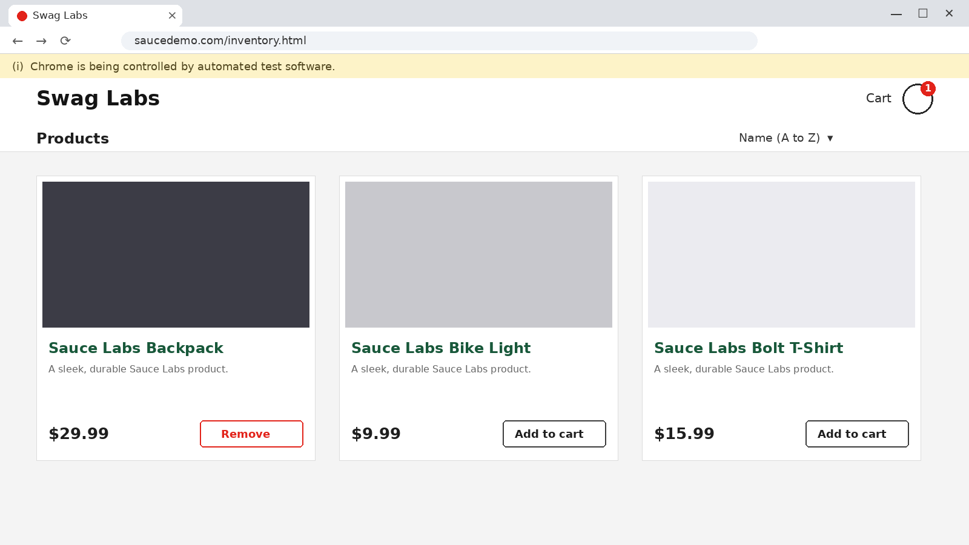
Figure 4: Sauce Labs Backpack added to the cart
Scenario WEB05: Open cart and validate
Scenario ID | WEB05
Scenario | Open cart and validate
Test Steps | 1. Click the cart icon.  2. Validate that "cart" is in the URL.  3. Verify the product in the cart.
Expected Result | Cart page opens with the selected product.
Actual Result | Cart page opens with the selected product.
Status | Pass
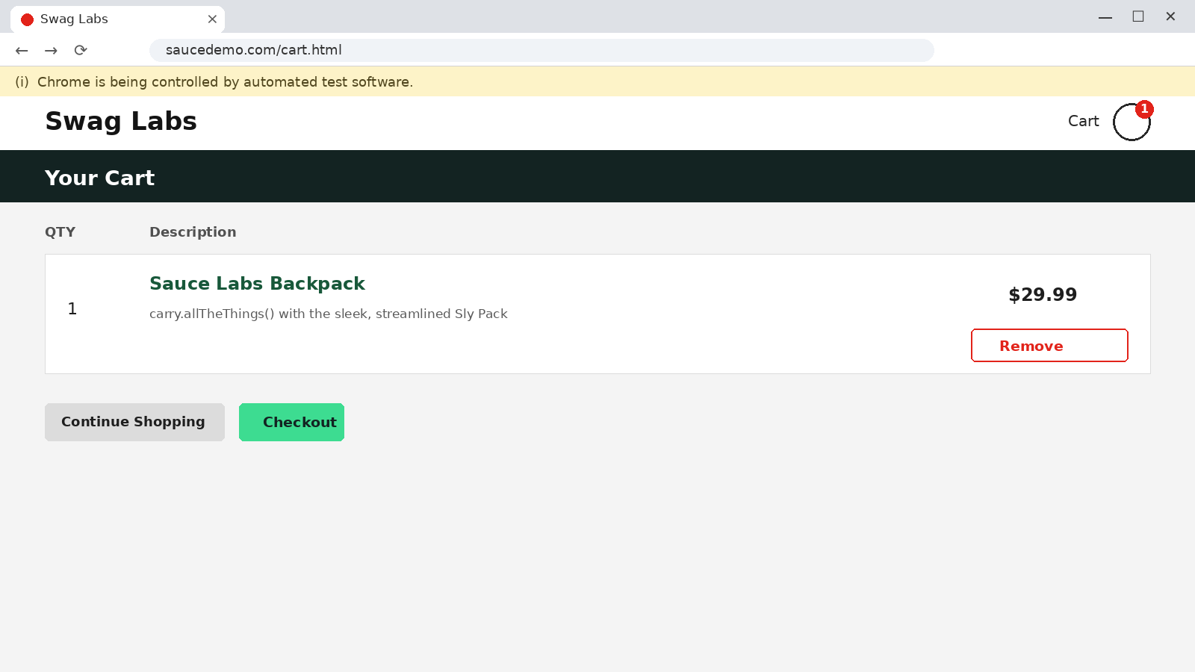
Figure 5: Cart page with the selected product

Source Code
from selenium import webdriver
from selenium.webdriver.common.by import By
from selenium.webdriver.support.ui import WebDriverWait
from selenium.webdriver.support import expected_conditions as EC

driver = webdriver.Chrome()
driver.maximize_window()
wait = WebDriverWait(driver, 10)

try:
# Browser Navigation
driver.get("https://www.saucedemo.com/")
print("Page Title:", driver.title)

# Form Handling
wait.until(
EC.visibility_of_element_located(
(By.ID, "user-name")
)
).send_keys("standard_user")

driver.find_element(
By.ID, "password"
).send_keys("secret_sauce")

# Web Element Interaction
driver.find_element(
By.ID, "login-button"
).click()

# Validation
wait.until(
EC.url_contains("inventory")
)
assert "inventory" in driver.current_url
print("Login Validation: PASS")

# Product Interaction
wait.until(
EC.element_to_be_clickable(
(By.ID, "add-to-cart-sauce-labs-backpack")
)
).click()
print("Product Selection: PASS")

# Cart Navigation
driver.find_element(
By.CLASS_NAME,
"shopping_cart_link"
).click()
assert "cart" in driver.current_url
print("Cart Navigation: PASS")

print("All Selenium Web Automation Tests Passed")

finally:
driver.quit()
Source Code Screenshots
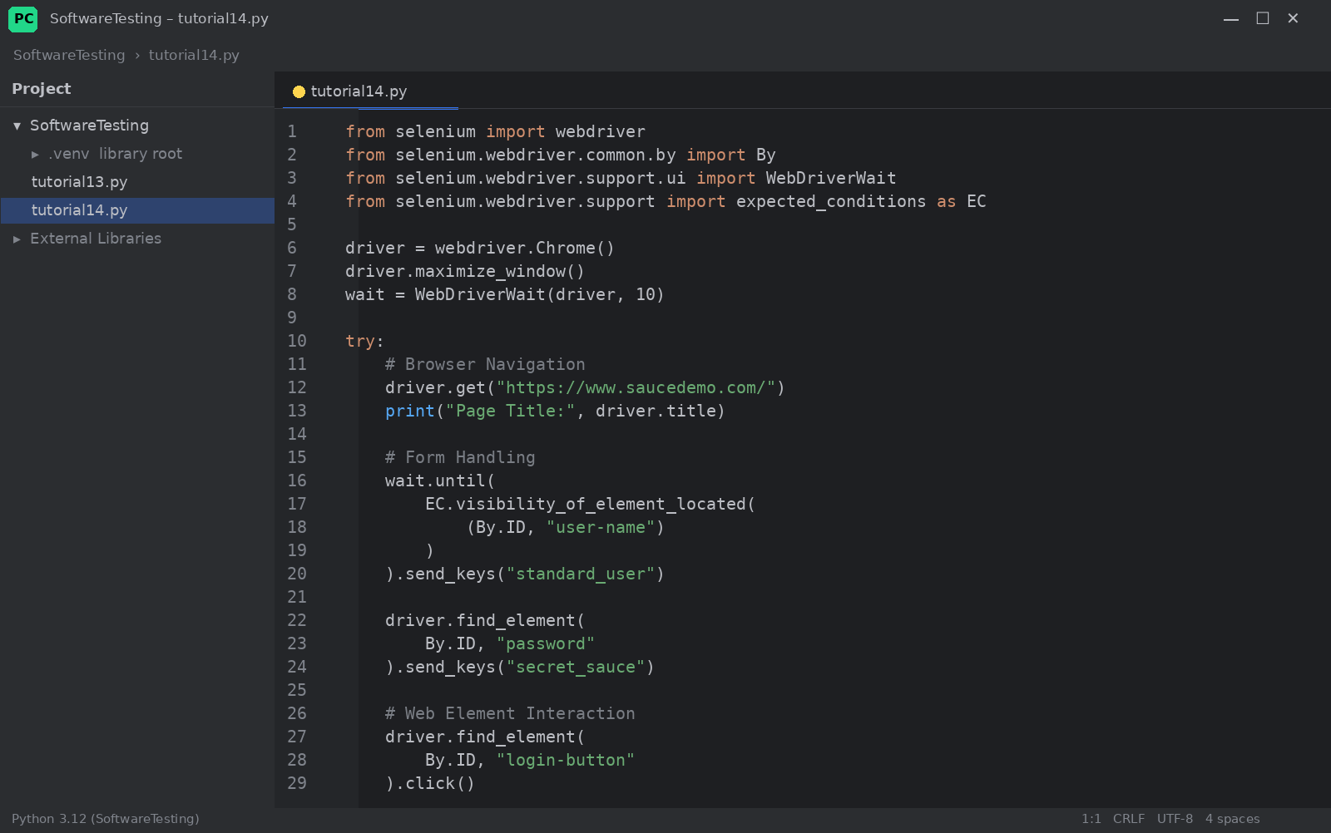
Figure 6: tutorial14.py (part 1)
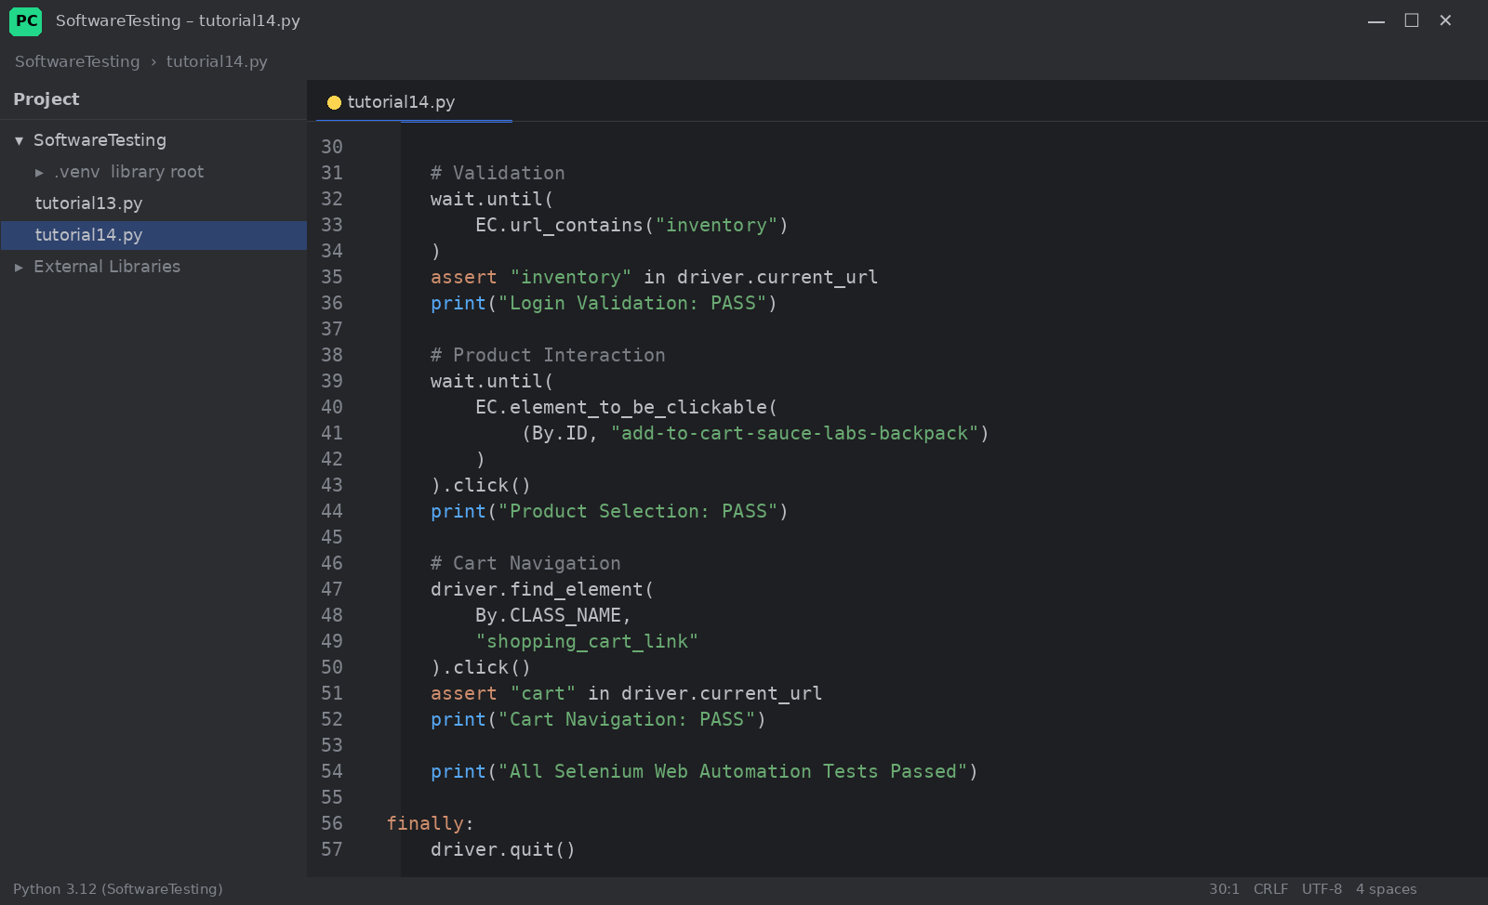
Figure 7: tutorial14.py (part 2)

Console Output
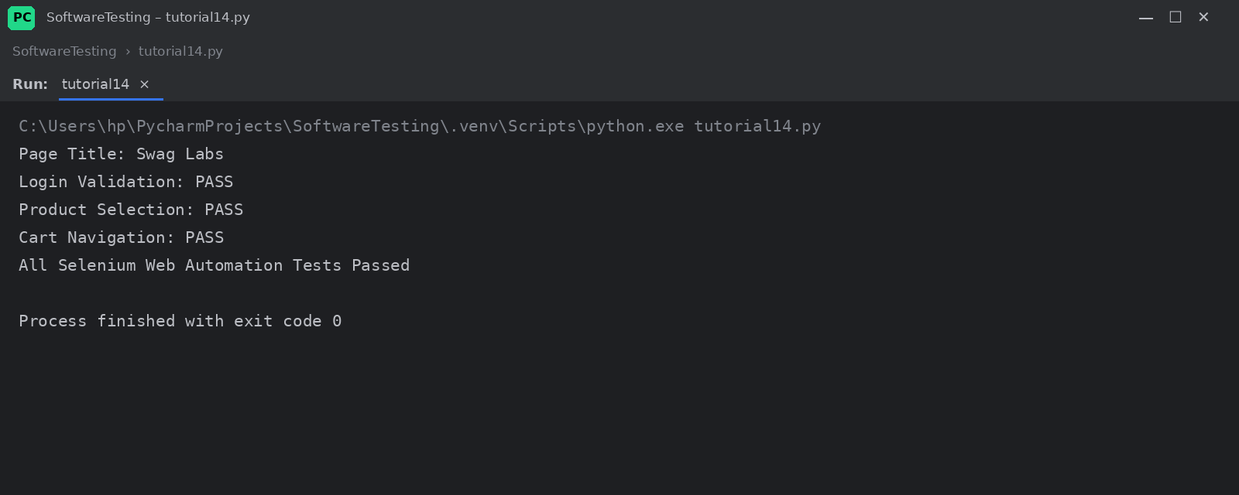
Figure 8: Console output of the executed script
Output:
Page Title: Swag Labs
Login Validation: PASS
Product Selection: PASS
Cart Navigation: PASS
All Selenium Web Automation Tests Passed

